Nama : Latifa Riska Aulia

NIM : 09010621010

EDA menggunakan Power BI

1. Histogram (petal length, petal width, sepal length, sepal width)

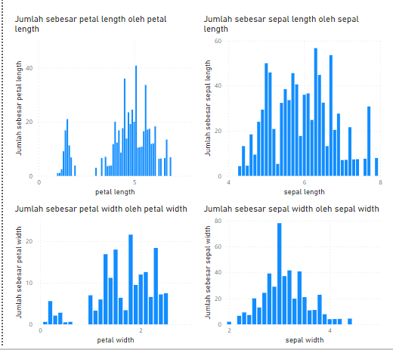

1. Rata-rata (petal length, petal width, sepal length, sepal width)

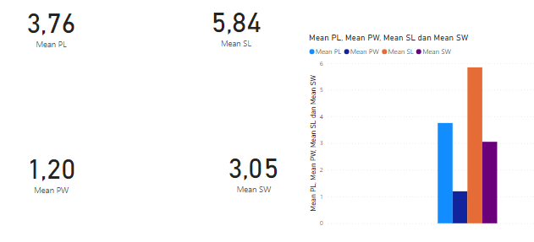

1. Median (petal length, petal width, sepal length, sepal width)

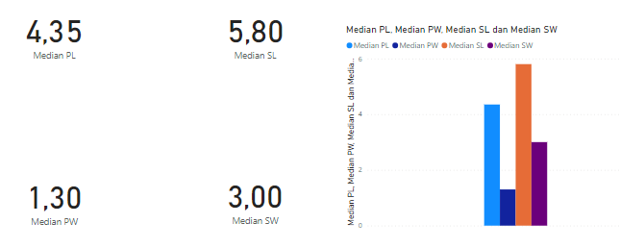

1. Nilai minimum (petal length, petal width, sepal length, sepal width)

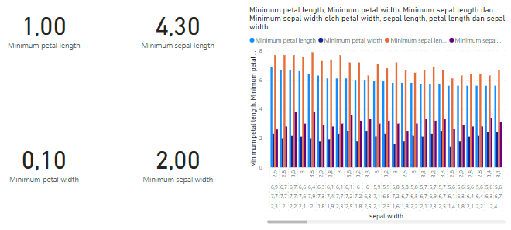

1. Nilai maximum (petal length, petal width, sepal length, sepal width)

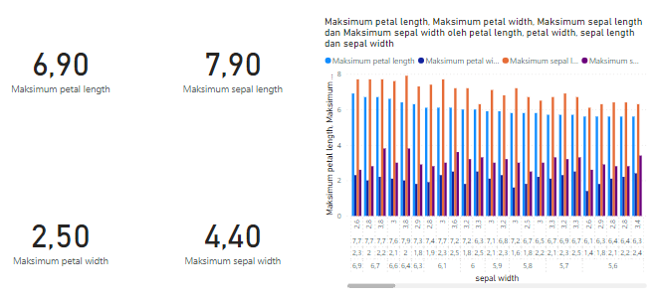

1. Standar deviasi (petal length, petal width, sepal length, sepal width)

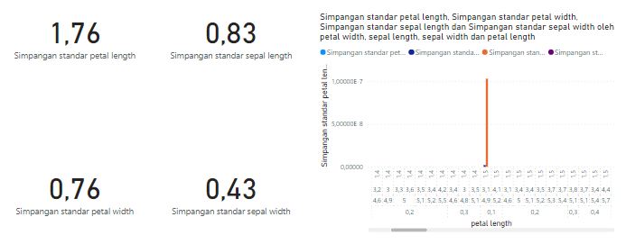

1. Sum/jumlah (petal length, petal width, sepal length, sepal width)

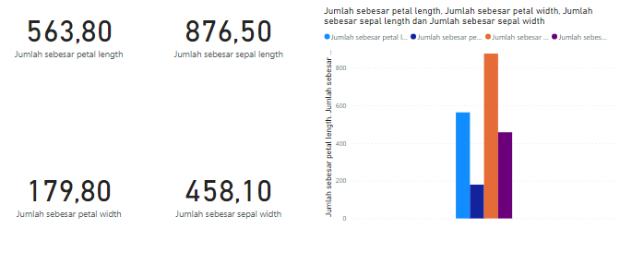

1. Varians (petal length, petal width, sepal length, sepal width)

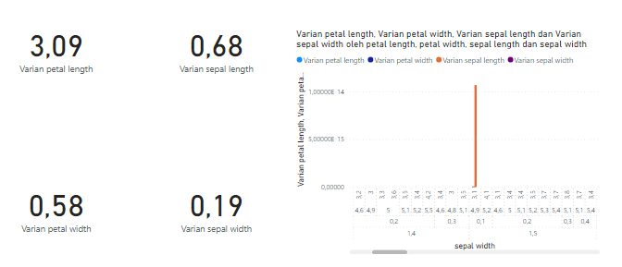

1. Modus (petal length, petal width, sepal length, sepal width)

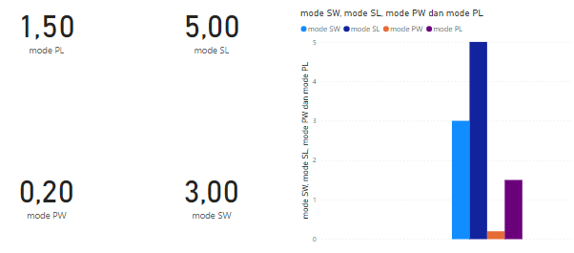

1. 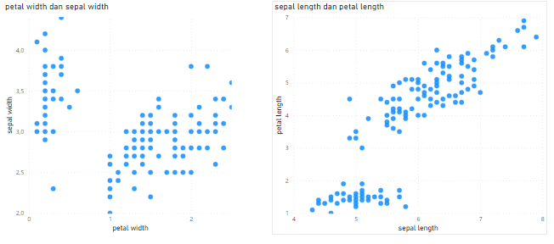Scatter plot (petal length, petal width, sepal length, sepal width)